How to change the IP Address in a Windows XP platform.

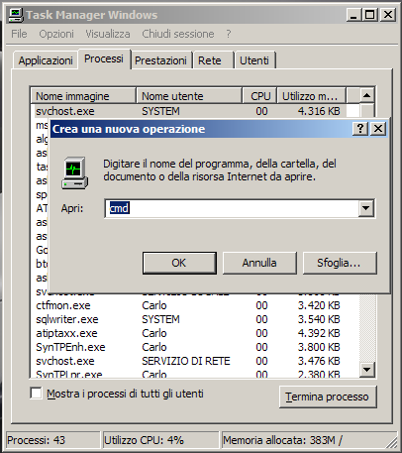
Press Ctrl + Alt + Delete to open the Windows Task Manager.
In the Task Manager click on “File” menu, then on “New Task (Run..)” submenu.
In the New Task windows digit “explorer.exe”.

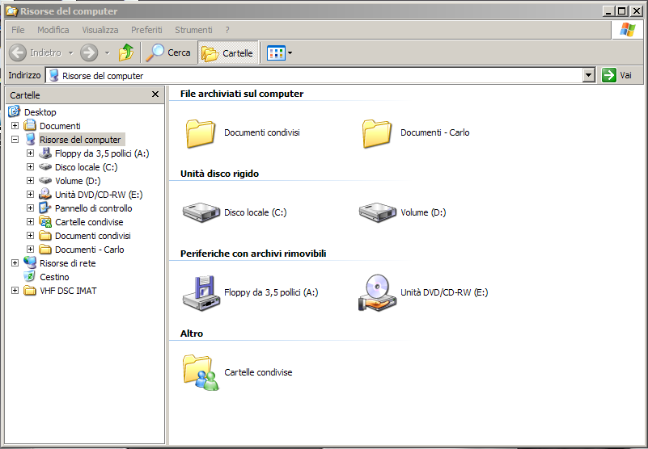

If in the Explorer window the Folder view is selected close it and from the left frame launch the “Control Panel”.
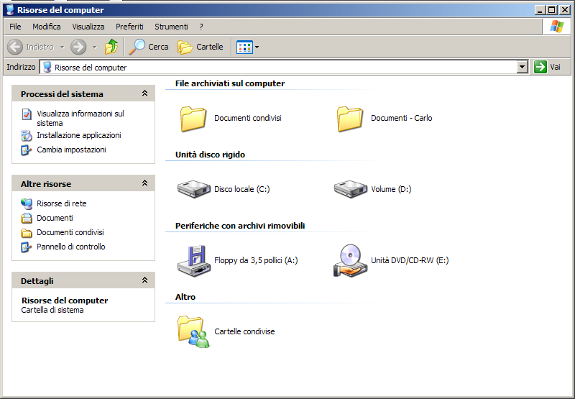
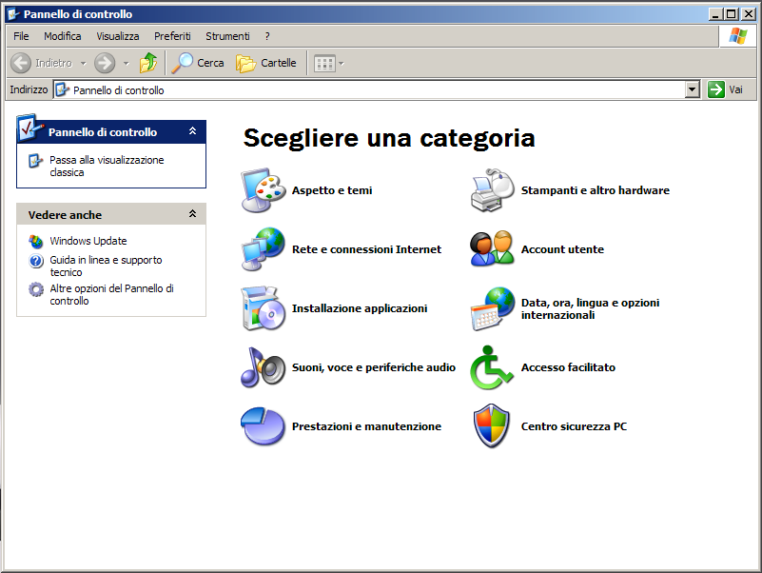

Click on the “Internet and Network Interfaces Icon”, then on “Network Interfaces”.
Right click on NetA and chose property.

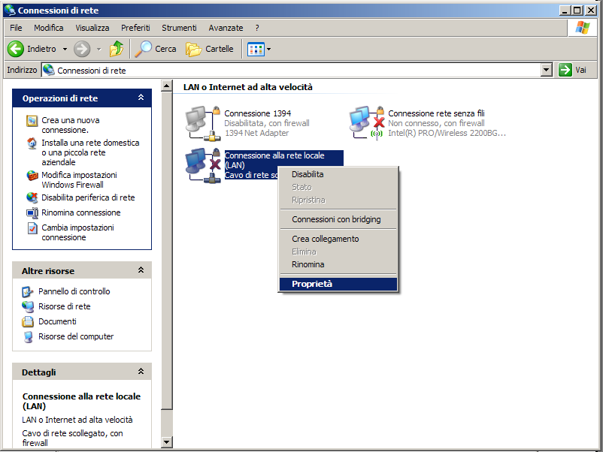

In the next window chose “Internet Protocol”, and click on the “Property” button.

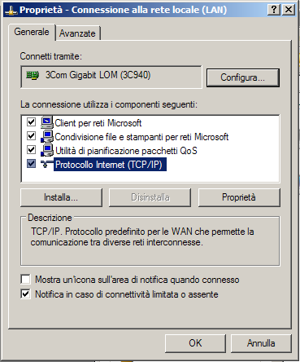

In the next window is possible to change the IP Address of the card.

